**CUSTOMISED VIRTUAL FILE SYSTEM (CVFS)**

This is research and development related project which implement UNIX file system.

**NAME OF PROJECT** :- Customised Virtual File System (CVFS)

**TECHNOLOGY USED** :- System programming using C language

**USER INTERFACE USED** :- Command user interface (CUI)

**PLATFORM REQUIRED** :- Windows NT or Linux Distribution System

**HARDWARE REQUIREMENTS** :- RAM – 512 MB, HDD – any size (preferably 1TB)

**SDK USED** :- No

**DESCRIPTION OF PROJECT** :-

This project is used to create customized virtual file system which can be work on Windows NT Platform .We are going to implement UNIX file system. This is command user interface based project which create file, open file, close file, close all file , write data in file, read data from file, give offset to file, view statistical data of file using stat or fstat function, clear screen, exit from menu.

**DATA STRUCTURE USED IN THE PROJECT** :-

1. SUPER BLOCK (BB)
2. UAREA
3. UFDT (Array)
4. FILE TABLE
5. INCORE INODE TABLE
6. DATA BLOCK
7. BUFFER CACHE

**DIAGRAM OF DATA STRUCTURE USED IN PROJECT** :-

1.Diagram of Hard Disk

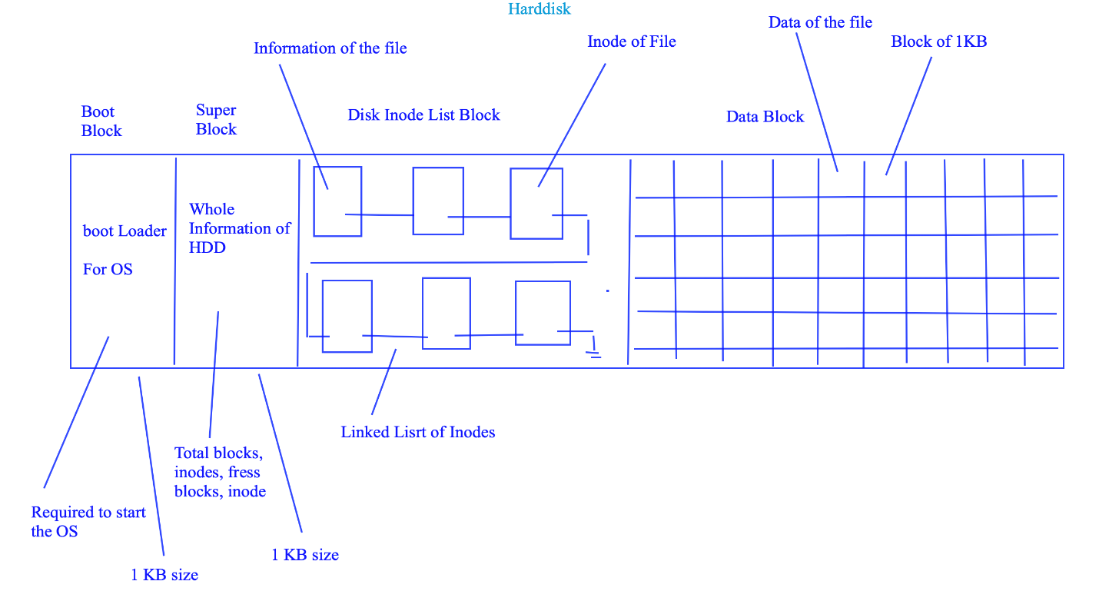

2.Diagram of whole process

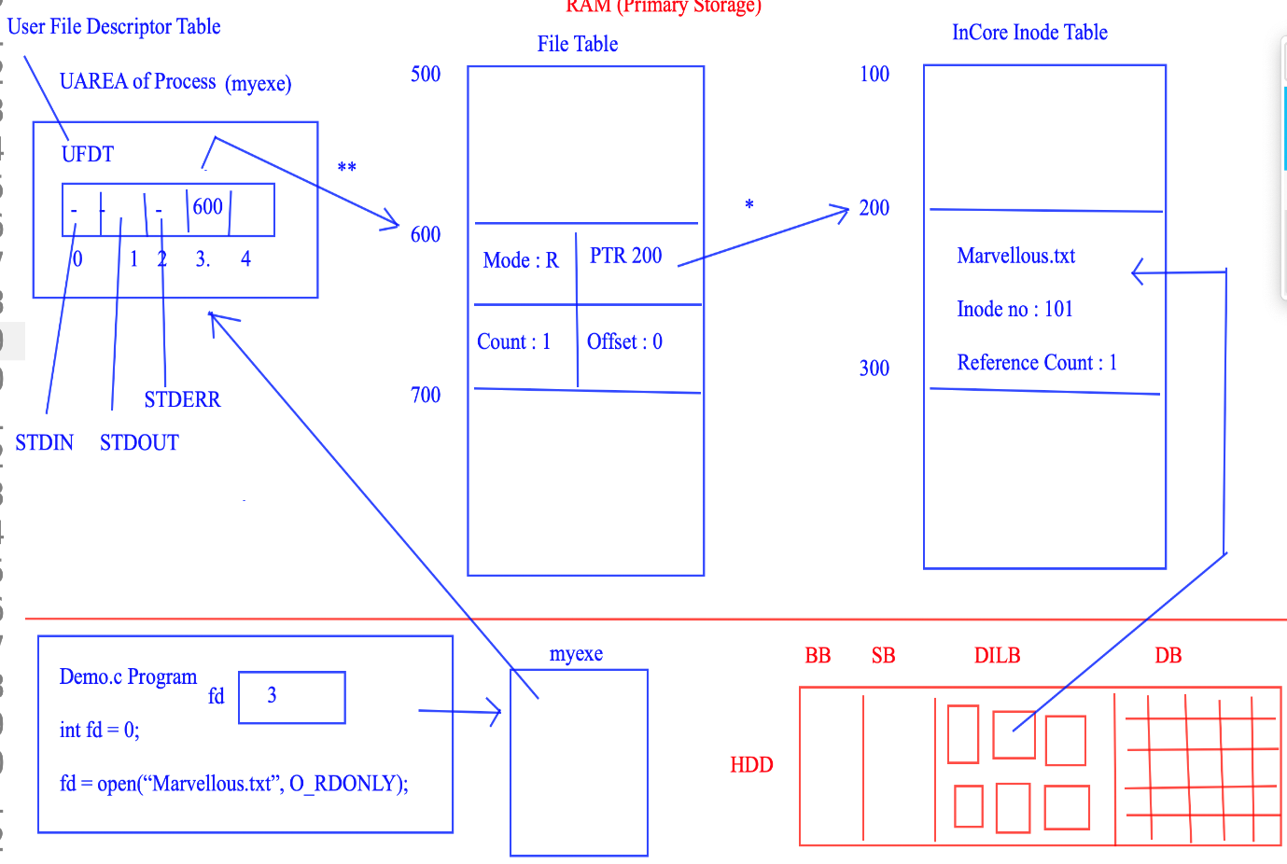

**System Calls Used I Project :-**

1. Open() -> It is used to open regular file
2. Close() -> It is used to close already opened file
3. Read() -> It is used to read data from file
4. Write() -> It is used to write data in file
5. Creat() -> It is used to cerate new file
6. Lseek() ->It is used to give offset to the file for reading purpose
7. Ls() ->It is used to display wholes file information
8. rm() -> It is used to delete file
9. chmod -> change access modes of file
10. unlink -> remove directory entry

**Actual code of project :-**

#include<stdio.h>

#include<stdlib.h>

#include<string.h>

#include<unistd.h>

#include<io.h>

#define MAXINODE 50

#define READ 1

#define WRITE 2

#define MAXFILESIZE 2048

#define REGULAR 1

#define SPECIAL 2

#define START 0

#define CURRENT 1

#define END 2

typedef struct superblock

{

int TotalInodes;

int FreeInode;

}SUPERBLOCK, *PSUPERBLOCK;

typedef struct inode

{

char FileName[50];

int InodeNumber;

int FileSize;

int FileActualSize;

int FileType;

char *Buffer;

int LinkCount;

int ReferenceCount;

int permission; // 1 23

struct inode *next;

}INODE,*PINODE,**PPINODE;

typedef struct filetable

{

int readoffset;

int writeoffset;

int count;

int mode; // 1 2 3

PINODE ptrinode;

}FILETABLE,*PFILETABLE;

typedef struct ufdt

{

PFILETABLE ptrfiletable;

}UFDT;

UFDT UFDTArr[50];

SUPERBLOCK SUPERBLOCKobj;

PINODE head = NULL;

void man(char *name)

{

if(name == NULL) return;

if(strcmp(name,"create") == 0)

{

printf("Description : Used to create new regular file\n");

printf("Usage : create File_name Permission\n");

}

else if(strcmp(name,"read") == 0)

{

printf("Description : Used to read data from regular file\n");

printf("Usage : read File_name No_Of_Bytes_To_Read\n");

}

else if(strcmp(name,"write") == 0)

{

printf("Description : Used to write into regular file\n");

printf("Usage : write File_name\n After this enter the data that we want to write\n");

}

else if(strcmp(name,"ls") == 0)

{

printf("Description : Used to list all information of files\n");

printf("Usage : ls\n");

}

else if(strcmp(name,"stat") == 0)

{

printf("Description : Used to display information of file\n");

printf("Usage : stat File_name\n");

}

else if(strcmp(name,"fstat") == 0)

{

printf("Description : Used to display information of file\n");

printf("Usage : stat File_Descriptor\n");

}

else if(strcmp(name,"truncate") == 0)

{

printf("Description : Used to remove data from file\n");

printf("Usage : truncate File_name\n");

}

else if(strcmp(name,"open") == 0)

{

printf("Description : Used to open existing file\n");

printf("Usage : open File_name mode\n");

}

else if(strcmp(name,"close") == 0)

{

printf("Description : Used to close opened file\n");

printf("Usage : close File_name\n");

}

else if(strcmp(name,"closeall") == 0)

{

printf("Description : Used to close all opened file\n");

printf("Usage : closeall\n");

}

else if(strcmp(name,"lseek") == 0)

{

printf("Description : Used to change file offset\n");

printf("Usage : lseek File_Name ChangeInOffset StartPoint\n");

}

else if(strcmp(name,"rm") == 0)

{

printf("Description : Used to delete the file\n");

printf("Usage : rm File_Name\n");

}

else

{

printf("ERROR : No manual entry available.\n");

}

}

void DisplayHelp()

{

printf("ls : To List out all files\n");

printf("clear : To clear console\n");

printf("open : To open the file\n");

printf("close : To close the file\n");

printf("closeall : To close all opened files\n");

printf("read : To Read the contents from file\n");

printf("write :To Write contents into file\n");

printf("exit : To Terminate file system\n");

printf("stat : To Display information of file using name\n");

printf("fstat :To Display information of file using file descriptor\n");

printf("truncate : To Remove all data from file\n");

printf("rm : To Delet the file\n");

}

int GetFDFromName(char *name)

{

int i = 0;

while(i<50)

{

if(UFDTArr[i].ptrfiletable != NULL)

if(strcmp((UFDTArr[i].ptrfiletable->ptrinode->FileName),name)==0)

break;

i++;

}

if(i == 50)

return -1;

else

return i;

}

PINODE Get_Inode(char * name)

{

PINODE temp = head;

int i = 0;

if(name == NULL)

return NULL;

while(temp!= NULL)

{

if(strcmp(name,temp->FileName) == 0)

break;

temp = temp->next;

}

return temp;

}

void CreateDILB()

{

int i = 1;

PINODE newn = NULL;

PINODE temp = head;

while(i<= MAXINODE)

{

newn = (PINODE)malloc(sizeof(INODE));

newn->LinkCount =0;

newn->ReferenceCount = 0;

newn->FileType = 0;

newn->FileSize = 0;

newn->Buffer = NULL;

newn->next = NULL;

newn->InodeNumber = i;

if(temp == NULL)

{

head = newn;

temp = head;

}

else

{

temp->next = newn;

temp = temp->next;

}

i++;

}

printf("DILB created successfully\n");

}

void InitialiseSuperBlock()

{

int i = 0;

while(i< MAXINODE)

{

UFDTArr[i].ptrfiletable = NULL;

i++;

}

SUPERBLOCKobj.TotalInodes = MAXINODE;

SUPERBLOCKobj.FreeInode = MAXINODE;

}

int CreateFile(char *name,int permission)

{

int i = 0;

PINODE temp = head;

if((name == NULL) || (permission == 0) || (permission > 3))

return -1;

if(SUPERBLOCKobj.FreeInode == 0)

return -2;

(SUPERBLOCKobj.FreeInode)--;

if(Get_Inode(name) != NULL)

return -3;

while(temp!= NULL)

{

if(temp->FileType == 0)

break;

temp=temp->next;

}

while(i<50)

{

if(UFDTArr[i].ptrfiletable == NULL)

break;

i++;

}

UFDTArr[i].ptrfiletable = (PFILETABLE)malloc(sizeof(FILETABLE));

UFDTArr[i].ptrfiletable->count = 1;

UFDTArr[i].ptrfiletable->mode = permission;

UFDTArr[i].ptrfiletable->readoffset = 0;

UFDTArr[i].ptrfiletable->writeoffset = 0;

UFDTArr[i].ptrfiletable->ptrinode = temp;

strcpy(UFDTArr[i].ptrfiletable->ptrinode->FileName,name);

UFDTArr[i].ptrfiletable->ptrinode->FileType = REGULAR;

UFDTArr[i].ptrfiletable->ptrinode->ReferenceCount = 1;

UFDTArr[i].ptrfiletable->ptrinode->LinkCount = 1;

UFDTArr[i].ptrfiletable->ptrinode->FileSize = MAXFILESIZE;

UFDTArr[i].ptrfiletable->ptrinode->FileActualSize = 0;

UFDTArr[i].ptrfiletable->ptrinode->permission = permission;

UFDTArr[i].ptrfiletable->ptrinode->Buffer = (char *)malloc(MAXFILESIZE);

return i;

}

// rm_File("Demo.txt")

int rm_File(char * name) //DELETE FILE

{

int fd = 0;

fd = GetFDFromName(name);

if(fd == -1)

return -1;

(UFDTArr[fd].ptrfiletable->ptrinode->LinkCount)--;

if(UFDTArr[fd].ptrfiletable->ptrinode->LinkCount == 0)

{

UFDTArr[fd].ptrfiletable->ptrinode->FileType = 0;

//free(UFDTArr[fd].ptrfiletable->ptrinode->Buffer);

free(UFDTArr[fd].ptrfiletable);

}

UFDTArr[fd].ptrfiletable = NULL;

(SUPERBLOCKobj.FreeInode)++;

}

int ReadFile(int fd, char *arr, int isize)

{

int read_size = 0;

if(UFDTArr[fd].ptrfiletable == NULL)

return -1;

if(UFDTArr[fd].ptrfiletable->mode !=READ && UFDTArr[fd].ptrfiletable->mode !=READ+WRITE)

return -2;

if(UFDTArr[fd].ptrfiletable->ptrinode->permission != READ && UFDTArr[fd].ptrfiletable->ptrinode->permission != READ+WRITE)

return -2;

if(UFDTArr[fd].ptrfiletable->readoffset == UFDTArr[fd].ptrfiletable->ptrinode->FileActualSize)

return -3;

if(UFDTArr[fd].ptrfiletable->ptrinode->FileType != REGULAR)

return -4;

read_size = (UFDTArr[fd].ptrfiletable->ptrinode->FileActualSize) - (UFDTArr[fd].ptrfiletable->readoffset);

if(read_size < isize)

{

strncpy(arr,(UFDTArr[fd].ptrfiletable->ptrinode->Buffer) + (UFDTArr[fd].ptrfiletable->readoffset),read_size);

UFDTArr[fd].ptrfiletable->readoffset = UFDTArr[fd].ptrfiletable->readoffset + read_size;

}

else

{

strncpy(arr,(UFDTArr[fd].ptrfiletable->ptrinode->Buffer) + (UFDTArr[fd].ptrfiletable->readoffset),isize);

(UFDTArr[fd].ptrfiletable->readoffset) = (UFDTArr[fd].ptrfiletable->readoffset) + isize;

}

return isize;

}

int WriteFile(int fd, char *arr, int isize)

{

if(((UFDTArr[fd].ptrfiletable->mode) !=WRITE) && ((UFDTArr[fd].ptrfiletable->mode) !=READ+WRITE))

return -1;

if(((UFDTArr[fd].ptrfiletable->ptrinode->permission) !=WRITE) && ((UFDTArr[fd].ptrfiletable->ptrinode->permission) != READ+WRITE))

return -1;

if((UFDTArr[fd].ptrfiletable->writeoffset) == MAXFILESIZE)

return -2;

if((UFDTArr[fd].ptrfiletable->ptrinode->FileType) != REGULAR)

return -3;

strncpy((UFDTArr[fd].ptrfiletable->ptrinode->Buffer) + (UFDTArr[fd].ptrfiletable->writeoffset),arr,isize);

(UFDTArr[fd].ptrfiletable->writeoffset) = (UFDTArr[fd].ptrfiletable->writeoffset )+ isize;

(UFDTArr[fd].ptrfiletable->ptrinode->FileActualSize) = (UFDTArr[fd].ptrfiletable->ptrinode->FileActualSize) + isize;

return isize;

}

int OpenFile(char *name, int mode)

{

int i = 0;

PINODE temp = NULL;

if(name == NULL || mode <= 0)

return -1;

temp = Get_Inode(name);

if(temp == NULL)

return -2;

if(temp->permission < mode)

return -3;

while(i<50)

{

if(UFDTArr[i].ptrfiletable == NULL)

break;

i++;

}

UFDTArr[i].ptrfiletable = (PFILETABLE)malloc(sizeof(FILETABLE));

if(UFDTArr[i].ptrfiletable == NULL)

return -1;

UFDTArr[i].ptrfiletable->count = 1;

UFDTArr[i].ptrfiletable->mode = mode;

if(mode == READ + WRITE)

{

UFDTArr[i].ptrfiletable->readoffset = 0;

UFDTArr[i].ptrfiletable->writeoffset = 0;

}

else if(mode == READ)

{

UFDTArr[i].ptrfiletable->readoffset = 0;

}

else if(mode == WRITE)

{

UFDTArr[i].ptrfiletable->writeoffset = 0;

}

UFDTArr[i].ptrfiletable->ptrinode = temp;

(UFDTArr[i].ptrfiletable->ptrinode->ReferenceCount)++;

return i;

}

void CloseFileByName(int fd)

{

UFDTArr[fd].ptrfiletable->readoffset = 0;

UFDTArr[fd].ptrfiletable->writeoffset = 0;

(UFDTArr[fd].ptrfiletable->ptrinode->ReferenceCount)--;

}

int CloseFileByName(char *name)

{

int i = 0;

i = GetFDFromName(name);

if(i == -1)

return -1;

UFDTArr[i].ptrfiletable->readoffset = 0;

UFDTArr[i].ptrfiletable->writeoffset = 0;

(UFDTArr[i].ptrfiletable->ptrinode->ReferenceCount)--;

return 0;

}

void CloseAllFile()

{

int i = 0;

while(i<50)

{

if(UFDTArr[i].ptrfiletable != NULL)

{

UFDTArr[i].ptrfiletable->readoffset = 0;

UFDTArr[i].ptrfiletable->writeoffset = 0;

(UFDTArr[i].ptrfiletable->ptrinode->ReferenceCount)--;

break;

}

i++;

}

}

int LseekFile(int fd, int size, int from)

{

if((fd<0) || (from > 2))

return -1;

if(UFDTArr[fd].ptrfiletable == NULL)

return -1;

if((UFDTArr[fd].ptrfiletable->mode == READ) || (UFDTArr[fd].ptrfiletable->mode == READ+WRITE))

{

if(from == CURRENT)

{

if(((UFDTArr[fd].ptrfiletable->readoffset) + size) > UFDTArr[fd].ptrfiletable->ptrinode->FileActualSize)

return -1;

if(((UFDTArr[fd].ptrfiletable->readoffset) + size) < 0)

return -1;

(UFDTArr[fd].ptrfiletable->readoffset) = (UFDTArr[fd].ptrfiletable->readoffset) + size;

}

else if(from == START)

{

if(size > (UFDTArr[fd].ptrfiletable->ptrinode->FileActualSize))

return -1;

if(size < 0)

return -1;

(UFDTArr[fd].ptrfiletable->readoffset) = size;

}

else if(from == END)

{

if((UFDTArr[fd].ptrfiletable->ptrinode->FileActualSize) + size > MAXFILESIZE)

return -1;

if(((UFDTArr[fd].ptrfiletable->readoffset) + size) < 0)

return -1;

(UFDTArr[fd].ptrfiletable->readoffset) = (UFDTArr[fd].ptrfiletable->ptrinode->FileActualSize) + size;

}

}

else if(UFDTArr[fd].ptrfiletable->mode == WRITE)

{

if(from == CURRENT)

{

if(((UFDTArr[fd].ptrfiletable->writeoffset) + size) > MAXFILESIZE)

return -1;

if(((UFDTArr[fd].ptrfiletable->writeoffset) + size) < 0)

return -1;

if(((UFDTArr[fd].ptrfiletable->writeoffset) + size) > (UFDTArr[fd].ptrfiletable->ptrinode->FileActualSize))

(UFDTArr[fd].ptrfiletable->ptrinode->FileActualSize) = (UFDTArr[fd].ptrfiletable->writeoffset) + size;

(UFDTArr[fd].ptrfiletable->writeoffset) = (UFDTArr[fd].ptrfiletable->writeoffset) + size;

}

else if(from == START)

{

if(size > MAXFILESIZE)

return -1;

if(size < 0)

return -1;

if(size > (UFDTArr[fd].ptrfiletable->ptrinode->FileActualSize))

(UFDTArr[fd].ptrfiletable->ptrinode->FileActualSize) = size;

(UFDTArr[fd].ptrfiletable->writeoffset) = size;

}

else if(from == END)

{

if((UFDTArr[fd].ptrfiletable->ptrinode->FileActualSize) + size > MAXFILESIZE)

return -1;

if(((UFDTArr[fd].ptrfiletable->writeoffset) + size) < 0)

return -1;

(UFDTArr[fd].ptrfiletable->writeoffset) = (UFDTArr[fd].ptrfiletable->ptrinode->FileActualSize) + size;

}

}

}

void ls_file()

{

int i = 0;

PINODE temp = head;

if(SUPERBLOCKobj.FreeInode == MAXINODE)

{

printf("Error : There are no files\n");

return;

}

printf("\nFile Name\tInode number\tFile size\tLink count\n");

printf(" \n");

while(temp != NULL)

{

if(temp->FileType != 0)

{

printf("%s\t\t%d\t\t%d\t\t%d\n",temp->FileName,temp->InodeNumber,temp->FileActualSize,temp->LinkCount);

}

temp = temp->next;

}

printf(" \n");

}

int fstat_file(int fd)

{

PINODE temp = head;

int i = 0;

if(fd < 0)

return -1;

if(UFDTArr[fd].ptrfiletable == NULL)

return -2;

temp = UFDTArr[fd].ptrfiletable->ptrinode;

printf("\n---------Statistical Information about file \n");

printf("File name : %s\n",temp->FileName);

printf("Inode Number %d\n",temp->InodeNumber);

printf("File size : %d\n",temp->FileSize);

printf("Actual File size : %d\n",temp->FileActualSize);

printf("Link count : %d\n",temp->LinkCount);

printf("Reference count : %d\n",temp->ReferenceCount);

if(temp->permission == 1)

printf("File Permission : Read only\n");

else if(temp->permission == 2)

printf("File Permission : Write\n");

else if(temp->permission == 3)

printf("File Permission : Read & Write\n");

printf(" \n\n");

return 0;

}

int stat_file(char *name)

{

PINODE temp = head;

int i = 0;

if(name == NULL)

return -1;

while(temp!= NULL)

{

if(strcmp(name,temp->FileName) == 0)

{

break;

}

temp = temp->next;

}

if(temp == NULL)

{

return -2;

}

printf("\n---------Statistical Information about file \n");

printf("File name : %s\n",temp->FileName);

printf("Inode Number %d\n",temp->InodeNumber);

printf("File size : %d\n",temp->FileSize);

printf("Actual File size : %d\n",temp->FileActualSize);

printf("Link count : %d\n",temp->LinkCount);

printf("Reference count : %d\n",temp->ReferenceCount);

if(temp->permission == 1)

printf("File Permission : Read only\n");

else if(temp->permission == 2)

printf("File Permission : Write\n");

else if(temp->permission == 3)

printf("File Permission : Read & Write\n");

printf(" \n\n");

return 0;

}

int truncate_File(char *name)

{

int fd = GetFDFromName(name);

if(fd == -1)

return -1;

memset(UFDTArr[fd].ptrfiletable->ptrinode->Buffer,0,1024);

UFDTArr[fd].ptrfiletable->readoffset = 0;

UFDTArr[fd].ptrfiletable->writeoffset = 0;

UFDTArr[fd].ptrfiletable->ptrinode->FileActualSize = 0;

}

int main()

{

char *ptr = NULL;

int ret = 0, fd = 0, count = 0;

char command[4][80], str[80], arr[1024];

InitialiseSuperBlock();

CreateDILB();

while(1)

{

fflush(stdin);

strcpy(str,"");

printf("\nSHUBHAM CVFS : > ");

fgets(str,80,stdin);// scanf("%[^'\n']s",str);

count = sscanf(str,"%s %s %s %s",command[0],command[1],command[2],command[3]);

if(count == 1)

{

if(strcmp(command[0],"ls") == 0)

{

ls_file();

}

else if(strcmp(command[0],"closeall") == 0)

{

CloseAllFile();

printf("All files closed successfully\n");

continue;

}

else if(strcmp(command[0],"cls") == 0)

{

system("cls");

continue;

}

else if(strcmp(command[0],"help") == 0)

{

DisplayHelp();

continue;

}

else if(strcmp(command[0],"exit") == 0)

{

printf("Terminating the customized Virtual File System project\n");

break;

}

else

{

printf("\nERROR : Command not found !!!\n");

continue;

}

}

else if(count == 2)

{

if(strcmp(command[0],"stat") == 0)

{

ret = stat_file(command[1]);

if(ret == -1)

printf("ERROR : Incorrect parameters\n");

if(ret == -2)

printf("ERROR : There is no such file\n");

continue;

}

else if(strcmp(command[0],"fstat") == 0)

{

ret = fstat_file(atoi(command[1]));

if(ret == -1)

printf("ERROR : Incorrect parameters\n");

if(ret == -2)

printf("ERROR : There is no such file\n");

continue;

}

else if(strcmp(command[0],"close") == 0)

{

ret = CloseFileByName(command[1]);

if(ret == -1)

printf("ERROR : There is no such file\n");

continue;

}

else if(strcmp(command[0],"rm") == 0)

{

ret = rm_File(command[1]);

if(ret == -1)

printf("ERROR : There is no such file\n");

continue;

}

else if(strcmp(command[0],"man") == 0)

{

man(command[1]);

}

else if(strcmp(command[0],"write") == 0)

{

fd = GetFDFromName(command[1]);

if(fd == -1)

{

printf("Error : Incorrect parameter\n");

continue;

}

printf("Enter the data : \n");

scanf("%[^\n]",arr);

ret = strlen(arr);

if(ret == 0)

{

printf("Error : Incorrect parameter\n");

continue;

}

ret = WriteFile(fd,arr,ret);

if(ret == -1)

printf("ERROR : Permission denied\n");

if(ret == -2)

printf("ERROR : There is no sufficient memory to write\n");

if(ret == -3)

printf("ERROR : It is not regular file\n");

}

else if(strcmp(command[0],"truncate") == 0)

{

ret = truncate_File(command[1]);

if(ret == -1)

printf("Error : Incorrect parameter\n");

}

else

{

printf("\nERROR : Command not found !!!\n");

continue;

}

}

else if(count == 3)

{

if(strcmp(command[0],"create") == 0)

{

ret = CreateFile(command[1],atoi(command[2]));

if(ret >= 0)

printf("File is successfully created with file descriptor : %d\n",ret);

if(ret == -1)

printf("ERROR : Incorrect parameters\n");

if(ret == -2)

printf("ERROR : There is no inodes\n");

if(ret == -3)

printf("ERROR : File already exists\n");

if(ret == -4)

printf("ERROR : Memory allocation failure\n");

continue;

}

else if(strcmp(command[0],"open") == 0)

{

ret = OpenFile(command[1],atoi(command[2]));

if(ret >= 0)

printf("File is successfully opened with file descriptor : %d\n",ret);

if(ret == -1)

printf("ERROR : Incorrect parameters\n");

if(ret == -2)

printf("ERROR : File not present\n");

if(ret == -3)

printf("ERROR : Permission denied\n");

continue;

}

else if(strcmp(command[0],"read") == 0)

{

fd = GetFDFromName(command[1]);

if(fd == -1)

{

printf("Error : Incorrect parameter\n");

continue;

}

ptr = (char *)malloc(sizeof(atoi(command[2]))+1);

if(ptr == NULL)

{

printf("Error : Memory allocation failure\n");

continue;

}

ret = ReadFile(fd,ptr,atoi(command[2]));

if(ret == -1)

printf("ERROR : File not existing\n");

if(ret == -2)

printf("ERROR : Permission denied\n");

if(ret == -3)

printf("ERROR : Reached at end of file\n");

if(ret == -4)

printf("ERROR : It is not regular file\n");

if(ret == 0)

printf("ERROR : File empty\n");

if(ret > 0)

{

write(2,ptr,ret);

}

continue;

}

else

{

printf("\nERROR : Command not found !!!\n");

continue;

}

}

else if(count == 4)

{

if(strcmp(command[0],"lseek") == 0)

{

fd = GetFDFromName(command[1]);

if(fd == -1)

{

printf("Error : Incorrect parameter\n");

continue;

}

ret = LseekFile(fd,atoi(command[2]),atoi(command[3]));

if(ret == -1)

{

printf("ERROR : Unable to perform lseek\n");

}

}

else

{

printf("\nERROR : Command not found !!!\n");

continue;

}

}

else

{

printf("\nERROR : Command not found !!!\n");

continue;

}

}

return 0;

}

**Function with their prototype and picture of running code :-**

1. After successful compilation of program. We can run executable file of program after that we can run various command as follows :-
2. **Create function** :-

**Prototype** :- creat file_Name Permission

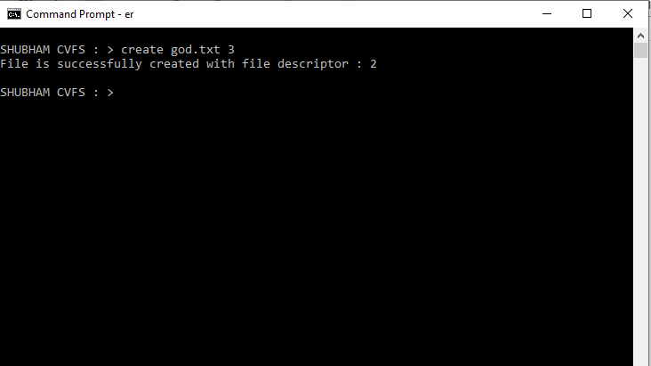**Description**  :- It can create file using file name and permission i.e. read(1) , write(2), read + write(3)

1. **Close all function** :-

**Prototype** :-closeall

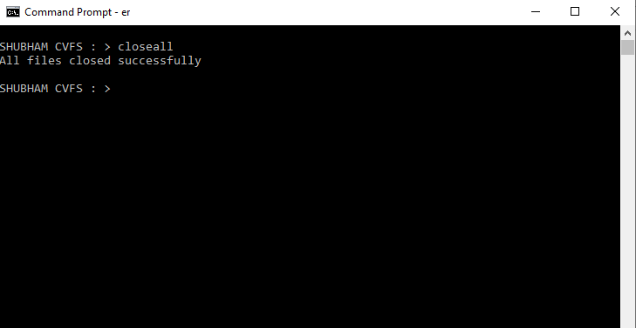**Description** :- It closed all opened file

1. **Open function** :-

**Prototype** :- open file_Name Mode

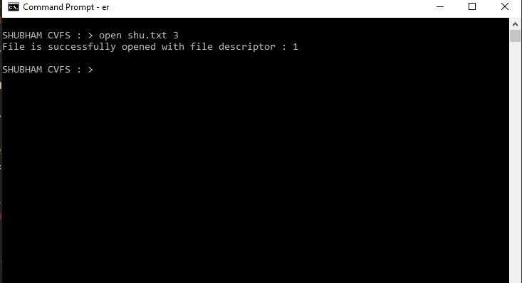**Description** :- open file using file name and mode i.e. read mode and write mode.

1. **Write function using file name**:-

**Prototype** :- write file_Name

**Description** :- after execution write data for insert in to file.

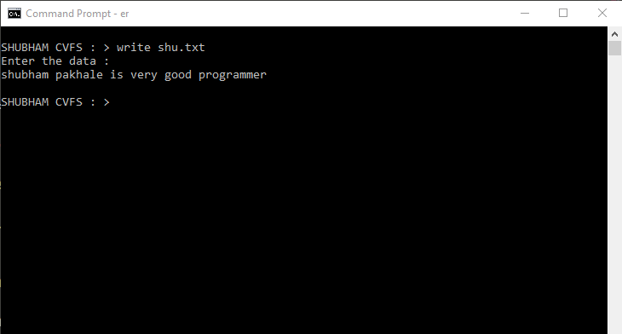

1. **Read function** :-

**Prototype** :- read file_Name size

**Description** :- read data from file which read no of bytes from file.

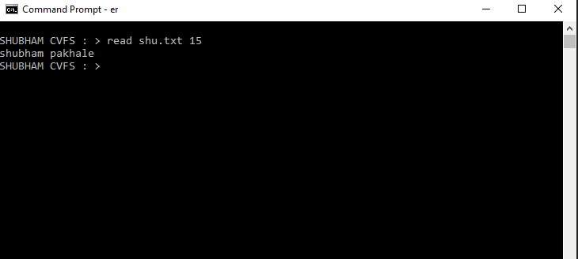

1. **Lseek function** :-

**Prototype** :-lseek file_Name changeInOffset StartPoint

**Description** :- It can change offset position for either read or write from given point. Means when we lseek file then after that each and every read and write function operate from that point.

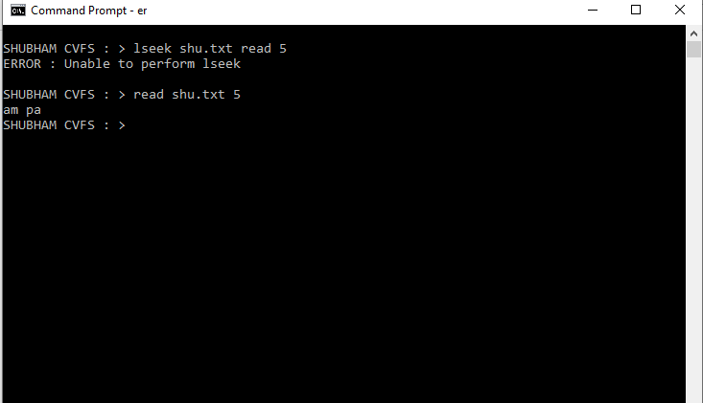

1. **Ls function** :-

**Prototype** :- ls

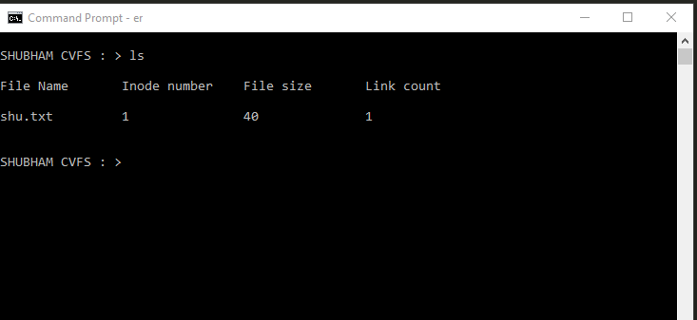**Desscription** :- It show all file name

1. **Rm function** :-

**Prototype** :- rm file_Name

**Description** :- It delete specific file.

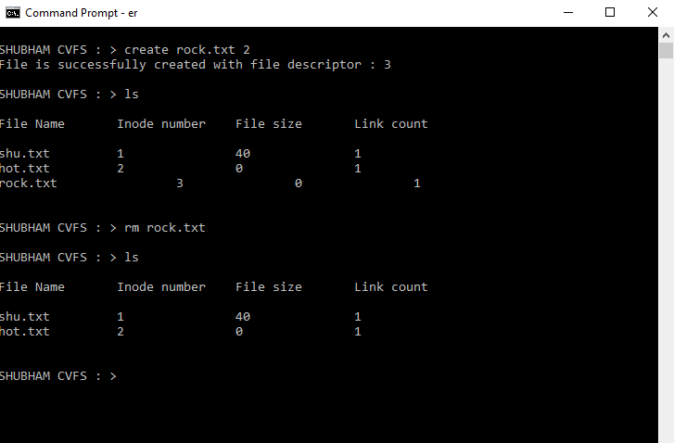

1. **Cls function** :-

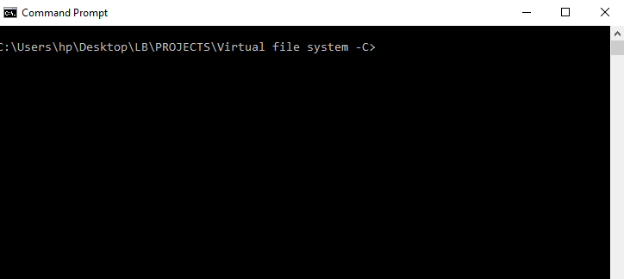**Prototype** :- cls

**Description** :- It clear screen.

1. **Help command** :-

**Prototype** :- help

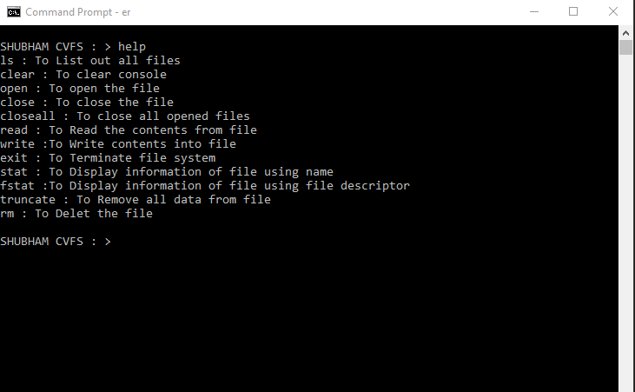**Description** :- It display all information that the program can implement following command.

1. **Man command** :-

**Prototype** :- man property_Name

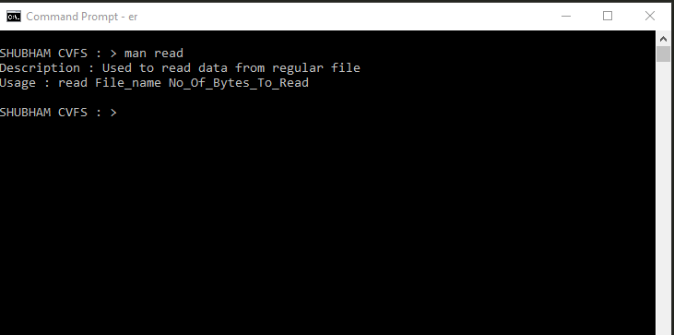**Description** :- Manpage shows all command argument list with prototype.

1. **Stat function** :-

**Prototype** :- stat file_Name

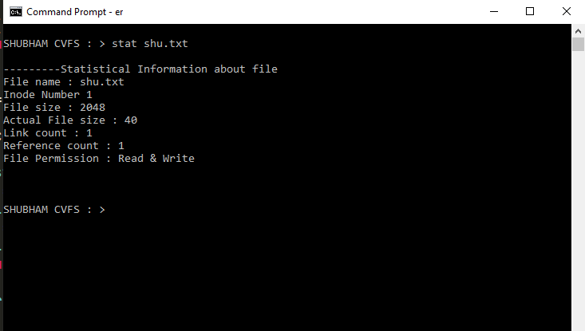**Description** :- It shows all statistical information of file using file name.

1. **Fstat function** :-

**Prototype** :- fstat file_descriptor

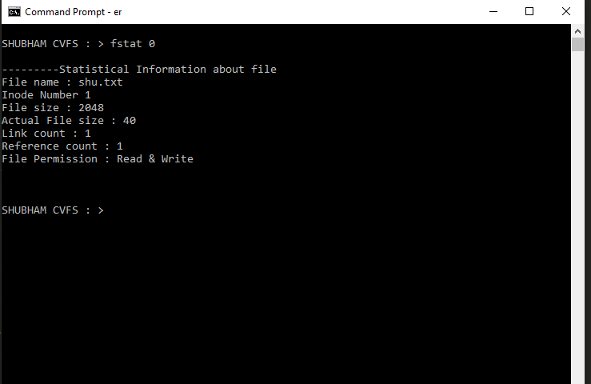**Description** :- It shows all statistical information of file using file descriptor.

1. **Exit function** :-

**Prototype** :- exit

**Description** :- It exit program. after exit command all files deleted.

